**BANK LOAN REPORT QUERY DOCUMENT**

1. Bank Loan Report

Total Loan Applications

SELECT COUNT(id) AS Total_Loan_Applications FROM Bank_loandata



Total Month To date Applications

SELECT COUNT(id) AS Total_Applications FROM bank_loandata

WHERE MONTH(issue_date) = 12



Previous Mounth to Date

SELECT SUM(loan_amount) AS PMTD_Total_Funded_Amount From Bank_loandata

WHERE MONTH(issue_date) = 11



**Total Funded Amount**

SELECT SUM(loan_amount) AS Total_Funded_Amount FROM bank_loandata



**MTD Total Funded Amount**

SELECT SUM(loan_amount) AS Total_Funded_Amount FROM bank_loandata

WHERE MONTH(issue_date) = 12



**PMTD Total Amount Recived**

SELECT SUM(loan_amount) AS Total_Funded_Amount FROM bank_loandata

WHERE MONTH(issue_date) = 11



**Total Amount Received**

SELECT SUM(total_payment) AS Total_Amount_Collected FROM bank_loandata



**MTD Total Amount Received**

SELECT SUM(total_payment) AS Total_Amount_Collected FROM bank_loandata

WHERE MONTH(issue_date) = 12



**PMTD Total Amount Received**

SELECT SUM(total_payment) AS Total_Amount_Collected FROM bank_loandata

WHERE MONTH(issue_date) = 11



**Avergae Intrest Rate :**

SELECT AVG(int_rate) AS AVG_Intrest_Rate FROM Bank_loandata



**MTD Average Interest**

SELECT AVG(int_rate) * 100 AS AVG_Intrest_Rate FROM Bank_loandata

HERE MONTH(issue_date) = 12



**PMTD Average Interest**

SELECT AVG(int_rate)*100 AS PMTD_Avg_Int_Rate FROM bank_loandata

WHERE MONTH(issue_date) = 11



**Avg DTI**

SELECT AVG(dti)*100 AS Avg_DTI FROM bank_loandata



**MTD Avg DTI**

SELECT AVG(dti)*100 AS MTD_Avg_DTI FROM bank_loandata

WHERE MONTH(issue_date) = 12



**PMTD Avg DTI**

SELECT AVG(dti)*100 AS PMTD_Avg_DTI FROM bank_loandata

WHERE MONTH(issue_date) = 11



**Good Loan Percentage**

SELECT

(COUNT(CASE WHEN loan_Status = 'Fully Paid' OR loan_status = 'Current' THEN id

END)* 100)

/

COUNT(id) AS Good_loan_percentage

FROM Bank_loandata



**Good Loan Applications**

SELECT COUNT(id) AS Good_Loan_Applications FROM Bank_loandata

WHERE loan_status = 'Fully Paid' OR loan_status = 'Current'



**Sum of GOOD LOAN Funded Amount**

SELECT SUM(loan_amount) AS Good_loan_Funded_Amount FROM Bank_loandata

WHERE loan_status = 'Fully Paid' OR loan_status = 'Current'



**Good loan Amount Recived**

SELECT SUM(total_payment) AS Good_loan_Funded_Amount FROM Bank_loandata

WHERE loan_status = 'Fully Paid' OR loan_status = 'Current'



**BAD LOAN ISSUED**

**Bad Loan Percentage**

SELECT

(COUNT(CASE WHEN Loan_status = 'Charged off' THEN id END) * 100.0)/

COUNT(id) AS Bad_Loan_percentage

FROM Bank_loandata



**Bad loan Applications**

SELECT COUNT(id) AS Bad_Loan_Application FROM Bank_loandata

WHERE loan_status = 'Charged Off'



**Bad Loan Funded Amount**

SELECT SUM(loan_amount) AS Bad_Loan_Funded_amount From Bank_loandata

WHERE loan_status = ' Charged Off ‘



**Bad Loan Amount Received**

SELECT SUM(total_payment)AS Bad_Loan_Funded_amount From Bank_loandata

WHERE loan_status = 'Charged Off'



LOAN STATUS

SELECT

loan_status,

COUNT(id) AS Total_loan_applications,

SUM(total_payment) AS Total_Amount_Recived,

SUM(loan_amount) AS Total_Funded_Amount,

AVG(int_rate * 100) AS Interest_rate,

AVG(dti * 100) AS DTI

FROM

Bank_loandata

GROUP BY

loan_status

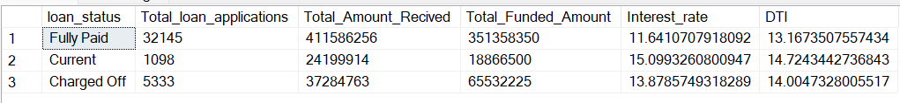

SELECT

loan_status,

SUM(total_payment) AS MTD_Total_Amount_Recived,

SUM(loan_amount) AS MTD_Total_Funded_Amount

FROM Bank_loandata

WHERE MONTH(issue_date) = 12

GROUP BY loan_status

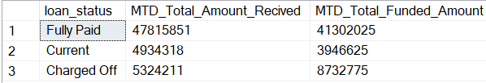

1. BANK LOAN REPORT

**MONTH**

SELECT

MONTH(issue_date) AS Month_Name,

DATENAME(MONTH,issue_date) AS Month_Name,

COUNT(id) AS Total_Loan_Applications,

SUM(loan_amount) AS Total_Funded_Amount,

SUM(total_payment) AS Total_Received_Amount

FROM Bank_loandata

GROUP BY MONTH(issue_date),DATENAME(MONTH ,issue_date)

ORDER BY MONTH(issue_date)

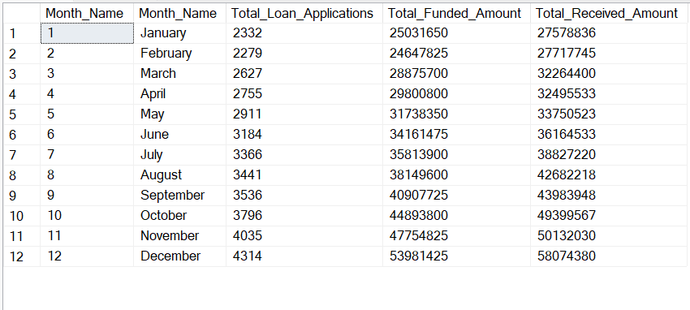

**STATE**

**Regional Analysic by State**

SELECT

address_state AS State,

COUNT(id) AS Total_Loan_Applications,

SUM(loan_amount) AS Total_Funded_Amount,

SUM(total_payment) AS Total_Amount_Received

FROM bank_loan_data

GROUP BY address_state

ORDER BY address_state

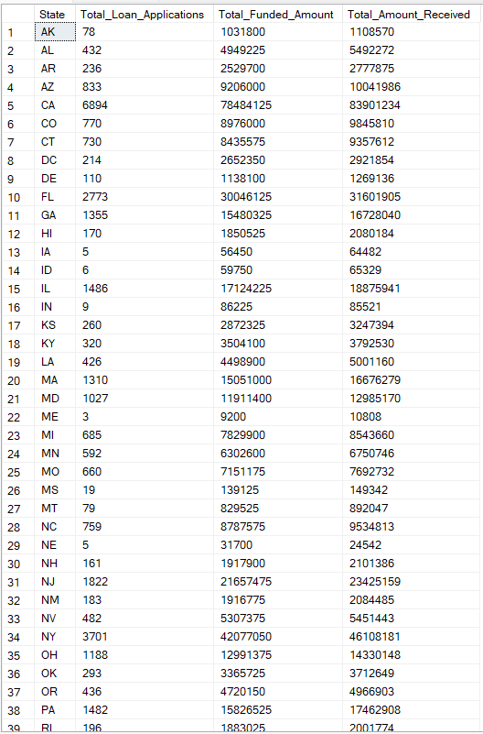

**Long Term Analysis**

SELECT

term,

COUNT(id) AS Total_Loan_Applications,

SUM(loan_amount) AS Total_Funded_Amount,

SUM(total_payment) AS Total_Recived_Amount

FROM bank_Loandata

GROUP BY term

ORDER BY term

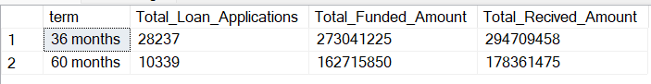

**Employee Length Analysis**

emp_length AS Employee_Length,

COUNT(id) AS Total_Loan_Applications,

SUM(loan_amount) AS Total_Funded_Amount,

SUM(total_payment) AS Total_Amount_Received

FROM bank_loandata

GROUP BY emp_length

ORDER BY emp_length

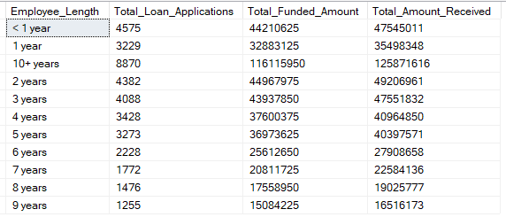

**Purpose of the Loan.**

SELECT

purpose,

COUNT(id) AS Total_Loan_Applications,

SUM(loan_amount) AS Total_Funded_Amount,

SUM(total_payment) AS Total_Recived_Amount

FROM bank_Loan_data

GROUP BY purpose

ORDER BY COUNT(id) DESC

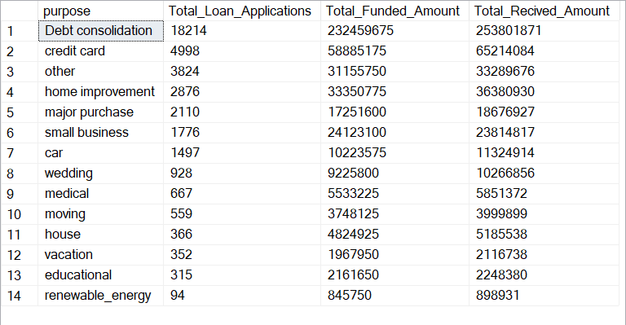

**Home_Ownership**

SELECT

home_ownership AS Home_Ownership,

COUNT(id) AS Total_Loan_Applications,

SUM(loan_amount) AS Total_Funded_Amount,

SUM(total_payment) AS Total_Amount_Received

FROM bank_loan_data

GROUP BY home_ownership

ORDER BY home_ownership

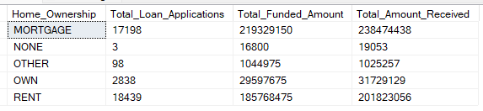

**NOTE: While Applying filter like grade A..**

SELECT

home_ownership,

COUNT(id) AS Total_Loan_Applications,

SUM(loan_amount) AS Total_Funded_Amount,

SUM(total_payment) AS Total_Recived_Amount

FROM bank_Loan_data

WHERE grade = 'A'

GROUP BY home_ownership

ORDER BY COUNT(id) DESC

